**Dear all students,**

**Follow the instructions carefully, please:**

* Kindly, you have 120 minutes to answer the following three questions, and **10 minutes of upload** time (not extendable).
* For the questions that you need to answer in the text, add your answer in this Word file and upload it into Moodle. For the questions that you need to write code, upload your Python file to Moodle. Rename both files using your English name or student ID.
* You can use Slides and class code examples.
* **Do not** use .rar or zip to upload answers; you must upload your Python code and Word file in Moodle.
* No need to mention that using the Internet or communicating during the exam is prohibited.
  + Cell phones are only in the pocket all the time (you must disconnect your computer from any wifi or internet network during the exam).

**Good Luck.**

--------------------------------------------------------------------------------------------------

English Name: Hsin-Yu, Chen

Chinese name: 陳昕佑

Student ID: 61375017H

--------------------------------------------------------------------------------------------------

**Questions:**

1. (a) In Figures 1 to 3 below, which model is our desired model to use for prediction? Explain briefly the reason, (b) explain what the two dashed lines (horizontal and vertical) mean in the Figure tradeoff. 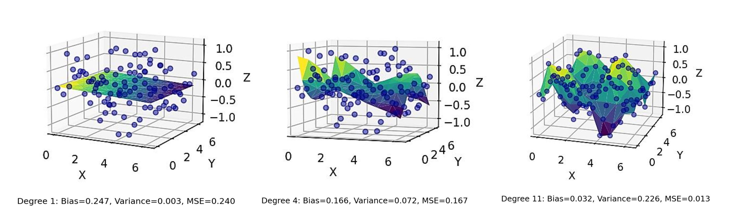

(1) (2) (3)

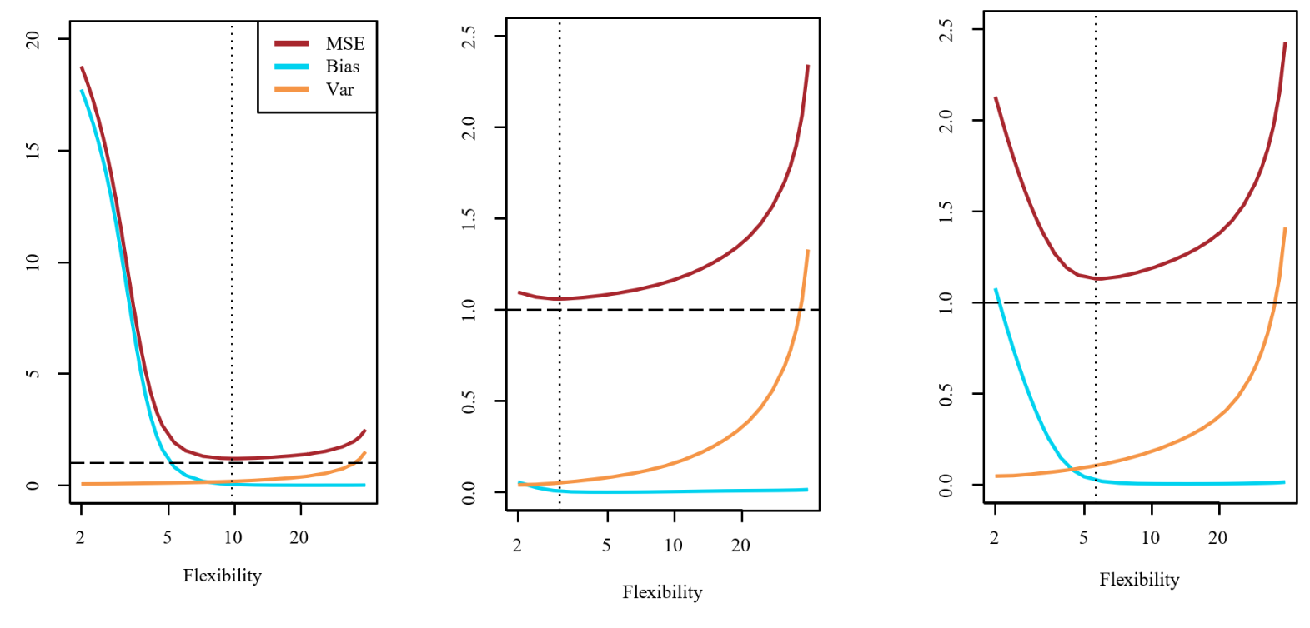

Figure. tradeoff

Answer:

1. The middle one is the desired model to use for prediction. The first model with higher bias shows the error from oversimplifying a real-world problem, leading to underfitting. The third one with high variance leads the model too sensitive to training data, makes predictions fluctuating a lot and overfitting.
2. Bias-variance tradeoff refers to the balance between the simplicity and flexibility of a model. The two dashed lines mean the sweet spot where the bias and variance are balanced.
3. (a) Why do we use cross-entropy in logistic regression? (b) Explain what we can understand from the confusion matrix below in detail,, and also mention what the colors mean.

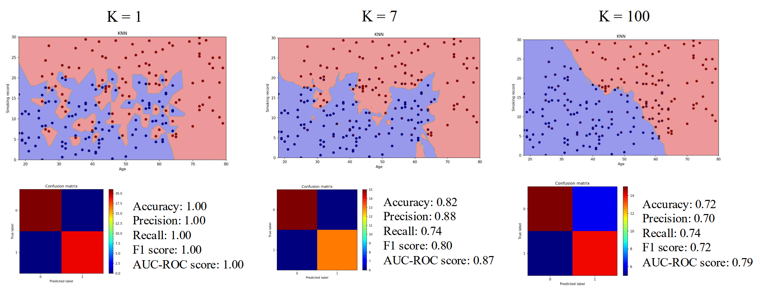

Answer:

1. Logistic function, also known as the sigmoid function, commonly used in logistic regression and other binary classification. In this case, we cannot use MSE or to write cost function for the logistic regression, so we use with negative log-likelihood function or crossentropy loss function.
2. In regression tasks for KNN assigns a numerical value based on the average of the k-nearest neighbors' target values , and this one shows the decision boundary for same example with K=7.

The confusion matrix is the most common evaluation metric to evaluate the performance of a classification algorithm, there are True Positive, False Positive, True Negative anf False Negative(from left to right, from up to down).

* Accuracy measures the overall proportion of correct predictions.
* Precision measures the proportion of positive predictions that are correct.
* Recall (sensitivity or true positive rate) measures the proportion of actual positives that are correctly predicted.
* F1-Score combines precision and recall into a single metric.
* Area Under the ROC Curve (AUC-ROC): The Receiver Operating Characteristic (ROC) we plot a curve as True Positive Rate (TPR) against the False Positive Rate (FPR) for different threshold values.

1. Complete and implement a linear regression model with SGD on the following data and report the k-fold cross-validation results for MSE, R-squared, and F-statistic with k = 6 after the models’ convergence.

import pandas as pd

import matplotlib.pyplot as plt

from mpl_toolkits.mplot3d import Axes3D

data = pd.DataFrame({

    'SocialMedia': [

        340.1, 154.5, 127.2, 261.5, 290.8, 115.7, 167.5, 230.2, 115.6, 309.8,

        176.1, 324.7, 130.8, 207.5, 314.1, 305.4, 177.8, 391.4, 179.2, 257.3,

        374.11, 169.95, 139.92, 287.65, 319.88, 127.27, 184.25, 253.22, 127.16, 340.78,

        193.71, 357.17, 143.88, 228.25, 345.51, 335.94, 195.58, 430.54, 197.12, 283.03,

        323.095, 146.775, 120.84, 248.425, 276.26, 109.915, 159.125, 218.69, 109.82, 294.31,

        167.295, 308.465, 124.26, 197.125, 298.395, 290.13, 168.91, 372.83, 170.24, 244.435

    ],

    'Billboard': [

        169.2, 145.1, 169.3, 157.5, 157.4, 182.0, 130.5, 118.6, 108.0, 128.2,

        123.2, 103.0, 164.9, 106.2, 145.0, 151.9, 213.0, 154.8, 117.3, 126.1,

        177.66, 152.355, 177.765, 165.375, 165.27, 191.1, 137.025, 124.53, 113.4, 134.61,

        129.36, 108.15, 173.145, 111.51, 152.25, 159.495, 223.65, 162.54, 123.165, 132.405,

        152.28, 130.59, 152.37, 141.75, 141.66, 163.8, 117.45, 106.74, 97.2, 115.38,

        110.88, 92.7, 148.41, 95.58, 130.5, 137.79, 193.05, 140.82, 106.57, 114.645

    ],

    'Sales': [

        29.1, 17.4, 16.3, 25.5, 19.9, 14.2, 18.8, 20.2, 11.8, 18.6,

        16.6, 23.4, 15.2, 15.7, 26.0, 29.4, 19.5, 31.4, 18.3, 21.6,

        30.371015, 17.714363, 17.538445, 27.397403, 20.80007, 14.751211, 20.826538, 21.55986, 13.139398, 19.204558,

        16.979135, 23.812623, 16.345842, 17.244362, 27.167014, 30.092623, 21.099325, 33.133781, 18.751607, 22.305827,

        27.667176, 15.608117, 15.723191, 24.124267, 19.01121, 13.662289, 18.241651, 19.730123, 10.968067, 17.680196,

        15.778138, 21.662496, 14.495963, 14.460843, 24.996702, 27.738864, 18.649246, 29.420281, 17.243353, 20.276602

    ]

})

fig = plt.figure(figsize=(10, 8))

ax = fig.add_subplot(111, projection='3d')

ax.scatter(data['SocialMedia'], data['Billboard'], data['Sales'], s=60)

ax.set_xlabel('Social Media Spend')

ax.set_ylabel('Billboard Spend')

ax.set_zlabel('Sales')

ax.set_title('3D Scatter Plot of Advertising Spend vs Sales')

plt.show()

**Note:** You can use the homework that you have already extended based on the given class example as homework (Chapter 5).

Attach the Python code to Moodle (do not compress files as .zip or .rar files)